**EXPERIMENT 2**

Circuit Diagram:

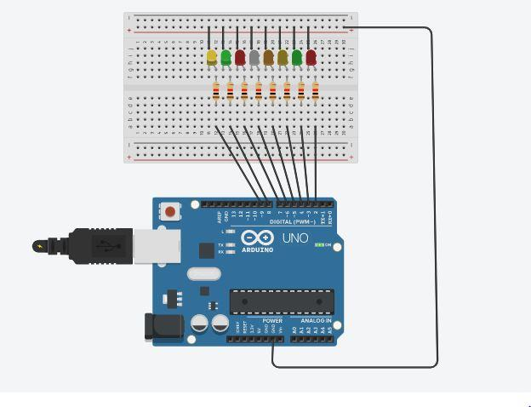

Theory:

Concept used: Various concepts are used in this experiment as listed:

1. Combination of LEDs in parallel circuit.
2. How to use multiple digital pins of Arduino Uno at the same time.
3. Algorithm to obtain chaser effect.

4.Connections in BreadBoard.

**Concept Used :**

A circuit is made in which four LEDs are connected in series with the resistors and resistors are connected to Arduino Board on different pins. The resistors are used to resist the flow of current in LEDs so that LEDs don’t get damage. The coding for Arduino is done in such a way that when stimulation is started, the LEDs starts blinking with the time gap of 1s one by one in the form of –

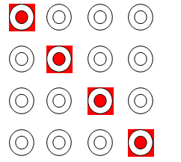

**Learning and Observations :**

* Making circuits using Breadboard.
* Connection four LEDs in Series on Breadboard.
* Using Multimeter to apply Resistance on a given LED.
* Working of Arduino UNO.
* Coding to be done on Arduino.exe for stimulation of the experiment.

**Problems and Troubleshooting:**

|  |
| --- |
|  |
| You should take care whether the board in the Arduino\UNO or not and also selection of port in tools. |
|  |

**Precautions**

|  |
| --- |
| While installing LED in bread board we should take care whether the terminals of LED connected or not. The two terminals should not be connected. Wires should be properly installed. Make sure resistance is connected. Arduino isn’t corrupt. |
|  |  |